**User guide**

**for Automatic Obstacle-Avoidance, Treasure-Identifying, and Photography Car**

**Group 28**

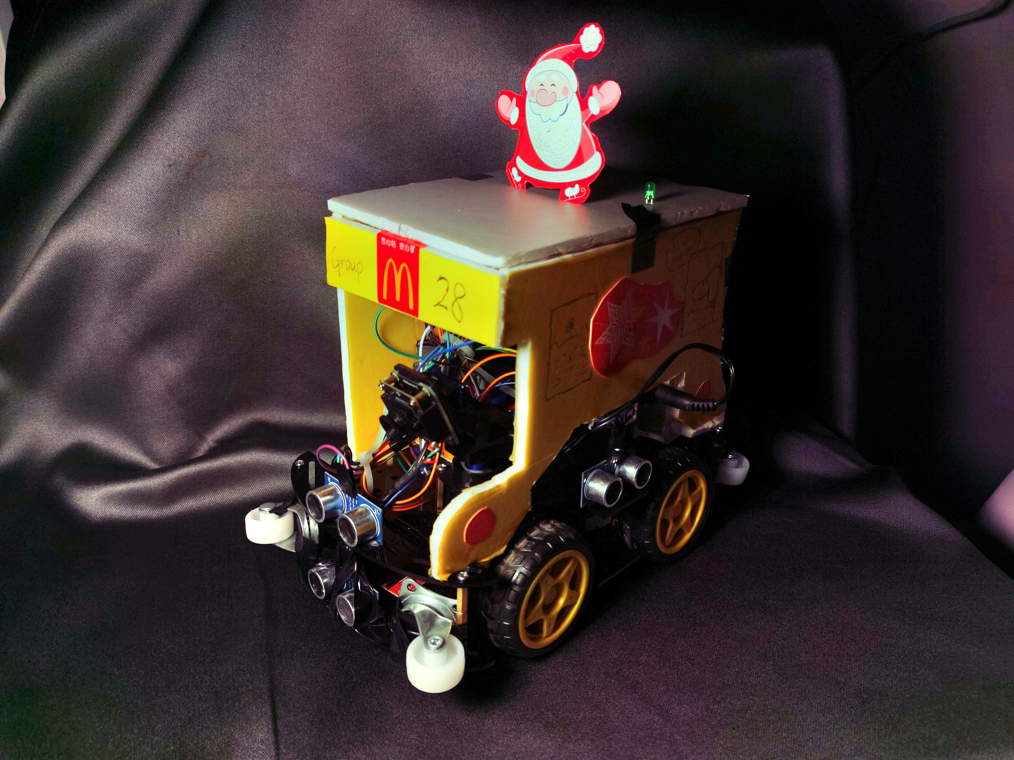

**Introduction**

The treasure hunting smart car with maze-solving robot is an automatic pathfinding car based on the Arduino control platform. It can automatically find the location of the treasure in a preset maze.

**composition**

1. .Main body of the treasure hunting smart car with maze-solving robot
2. Arduino nano control board
3. Infrared sensor
4. Motor drive module
5. Battery box
6. Screwdriver
7. DuPont wires
8. Ultrasonic sensor
9. L298N Motor Driver
10. Camera
11. IMU948 gyroscope

**Usage Method**

1. Hardware Setup:

• The code uses an Arduino board with various components, including motor drivers (L298N), ultrasonic sensors (front, left, right, and low), servos for camera movement, and an LED for indication.

• The car has four motors (front left, front right, back left, and back right) for movement.

2. Sensors and Control:

• Ultrasonic sensors (front, left, right, and low) are used to measure distances in different directions, helping the car navigate and avoid obstacles.

3. Main Loop (Loop Function):

• The explore() function is called repeatedly to explore the maze.

4. Explore Function:

• It starts by checking the distance in front (d_front). If the distance is too short, it moves backward to avoid collisions.

• The car then checks the distance in front again. If there’s enough space, it moves forward and tries to maintain a certain distance from walls on its sides.

• If there’s a wall in front, it checks distances on the left and right to decide which way to turn.

• If the car encounters walls in all three directions, it checks for treasure using detectTreasure(). If treasure is detected, it takes pictures.

• If no treasure is detected or when in doubt, the car turns around 180 degrees to explore in the opposite direction.

5. Obstacle Avoidance:

• The correctDirection() function is used to keep the car away from walls on its sides. It checks the left and right distances and, if necessary, turns in the opposite direction to maintain a safe distance.

6. Treasure Detection:

• The detectTreasure() function checks if a low obstacle is detected (possibly a treasure). If so, it signals the detection using the LED and takes pictures using the servo-controlled camera.

7. Motor Control:

• Various functions (forward(), backward(), turnLeft(), turnRight(), and turnAround()) control the car’s motor movements based on the direction needed. Speed adjustments are made using the setSpeed() function.

8. Camera Control:

• The servo-controlled camera rotates to capture images when treasure is detected.

1. Magnetometer Module:

We utilize the magnetometer feature in the IMU948 gyroscope to acquire the real-time two-dimensional coordinates of the car. The IMU948 module connects to the computer via its built-in Bluetooth. A Python program reads the coordinates to serve as the car's real-time location and uses this information to plot the car's trajectory.

10. WiFi module

We use a WiFi module to transmit real-time video streams from the camera. These streams are forwarded to a neural network model specialized in IoT (Internet of Things). Utilizing the Flask framework, we send the recognition results and images back to the e-commerce specialized database through the response command.

1. 12. Ultrasonic sensor module : The ultrasonic sensor module is a device used in the Arduino trolley project to achieve distance measurement and obstacle avoidance functions by emitting ultrasonic pulses and measuring their return time. This sensor module can be combined with the Arduino development board to help your car achieve intelligent obstacle avoidance and positioning functions.

## Maintenance and upkeep

In order to maintain the normal operation of the car for a long time, we suggest that you follow the following methods for maintenance and upkeep:

1. Do not shake the car frequently, as doing so will easily loosen the wire connections of the car.

2. Regularly clean the dust on the car to ensure the normal operation of the car's circuit.

3. Regularly check whether the various accessories and connections of the car are loose or disconnected, and if necessary, please fix the

## Use safety

There are no hazardous parts in this car, but please pay attention to the following safety regulations when using it.

1. Do not short-circuit the battery or spill liquid onto the car during use.
2. This car has many small parts. Please keep children away from them when using it to prevent them from swallowing small parts and placing them out of reach of children.
3. Do not place the car next to liquids or flammable materials, which may cause danger.